Name: _____Logan Passi________  
Date: _____________________

1. What is the difference between preemptive and nonpreemptive scheduling? – 1pt  
     
     
   Nonpreemptive scheduling keeps the CPU until it releases it by terminating or switching to the waiting state.

Preemptive scheduling will pause or stop a lower priority process for a higher priority process

1. Perform FCFS scheduling on the following process schedule (assume each process comes in right after another) and state the average wait time  
   Hint: Do a gnatt chart for each – 4pt

a)

|  |  |
| --- | --- |
| Process | Burst Time |
| P1 | 24 |
| P2 | 3 |
| P3 | 3 |

b)

|  |  |
| --- | --- |
| Process | Burst Time |
| P1 | 10 |
| P2 | 8 |
| P3 | 2 |
| P4 | 1 |

c)

|  |  |
| --- | --- |
| Process | Burst Time |
| P1 | 1 |
| P2 | 1 |
| P3 | 1 |
| P4 | 5 |

| P1 | P2 | P3| | P1 | P2 | P3 | P4 | | P1 | P2 | P3 | P4 | 0 – 24 – 27 - 30 0 - 10 - 18 - 20 - 21 0 - 1 - 2 - 3 - 8  
  
(0 + 24 + 27)/3 = 17 (0+10+18+20)/4 = 12 (0+1+2+3)/4 = 1.5

1. Perform SJFS nonpreemptive and preemptive scheduling on the following process schedule (assume each process comes in right after another) and state the average wait time  
   Hint: Do a gnatt chart for each – 8pt

Hint 2: Ignore Arrival times for SJFS nonpreemptive

Hint 3: You should have 4 answers with 4 different gnat charts

a)

|  |  |  |
| --- | --- | --- |
| Process | Burst Time | Arrival |
| P1 | 6 | 0 |
| P2 | 8 | 1 |
| P3 | 7 | 2 |
| P4 | 3 | 3 |

b)

|  |  |  |
| --- | --- | --- |
| Process | Burst Time | Arrival |
| P1 | 5 | 0 |
| P2 | 8 | 1 |
| P3 | 6 | 2 |
| P4 | 1 | 3 |

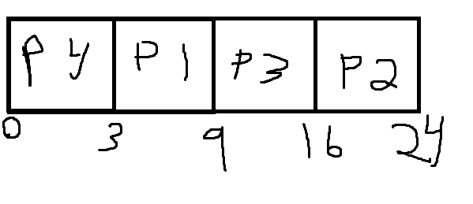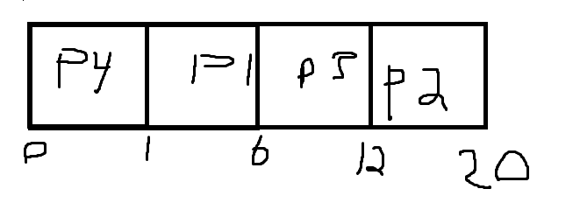

(0+3+9+16)/4 = 7 (0+1+6+12)/4 = 4.75

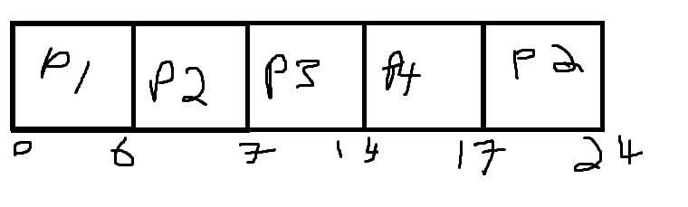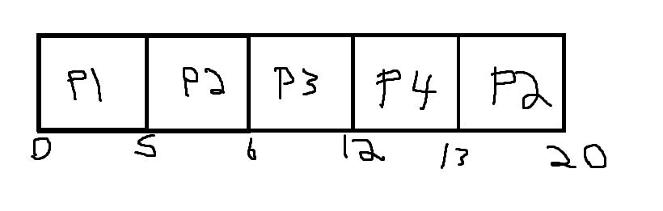

(0+10+0+0)/4 = 2.5 (0+7+0+0)/4= 1.75

1. Perform Priority scheduling on the following process schedule (assume each process comes in right after another) and state the average wait time

Hint: Assume non-preemptive  
Hint: Do a gnatt chart for each – 4pt

a)

|  |  |  |  |
| --- | --- | --- | --- |
| Process | Burst Time | | Priority |
| P1 | 10 | 3 | |
| P2 | 1 | 1 | |
| P3 | 2 | 4 | |
| P4 | 1 | 5 | |
| P5 | 5 | 2 | |

b)

|  |  |  |
| --- | --- | --- |
| Process | Burst Time | Priority |
| P1 | 8 | 1 |
| P2 | 5 | 5 |
| P3 | 3 | 4 |
| P4 | 1 | 3 |
| P5 | 2 | 2 |

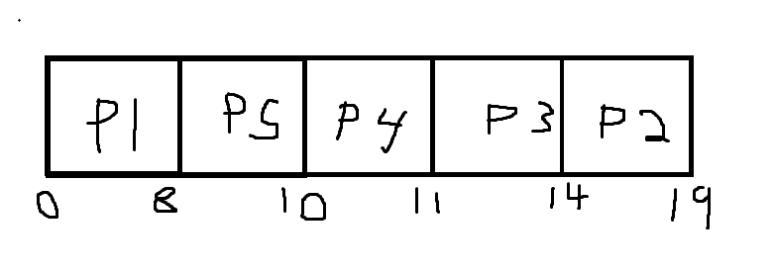

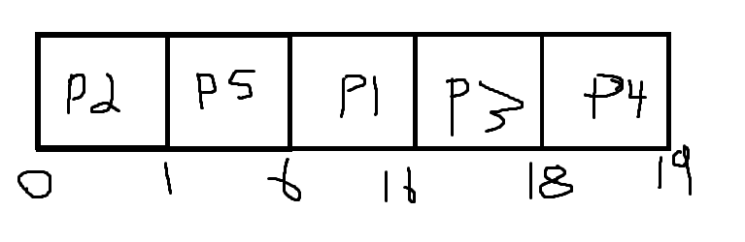

(0+1+6+16+18)/5 = 8.2 (0+8+10+11+14)/5 = 8.6

1. Perform Round Robin scheduling on the following process schedule (assume each process comes in right after another) and state the average wait time  
   Hint: Do a gnatt chart for each

Hint: Assume a time quantum of 4ms – 4pt

a)

|  |  |
| --- | --- |
| Process | Burst Time |
| P1 | 24 |
| P2 | 3 |
| P3 | 3 |

b)

|  |  |
| --- | --- |
| Process | Burst Time |
| P1 | 24 |
| P2 | 3 |
| P3 | 3 |
| P4 | 5 |

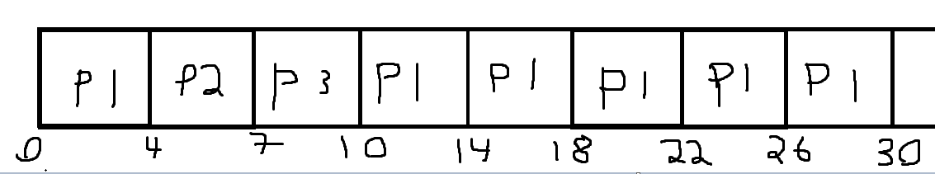

(4+7+6)/3 = 5.67

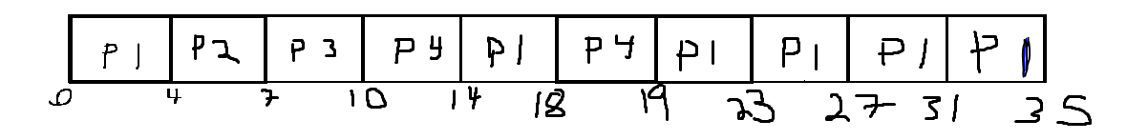

(4+7+14+11)/4 = 9

Extra credit:

Write a program to automate each of the scheduling algorithms. – 2pt/algorithm

Input should be the process schedule, output should be a list of processes, their start time and average wait time.

You will get partial credit if you don’t finish all algorithms. You can write it in any language you want.